Daniel Boone Council
2011 Annual Report

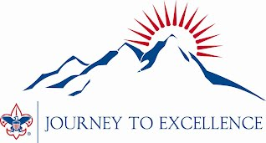

Table of Contents

Your Return on Investment

Membership Statistics

Finance Statistics

2011-2012 Executive Board Roster

2011-2012 District Chairmen and Commissioners

2011 Eagle Scouts

Chartered Organizations

Treasurer’s Report
- Year-end Operating Statement (Statement of Operations)
- Year-end Balance Sheet (Financial Position Statement)

Your Return on Investment

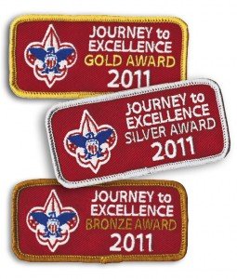
- Area 5 Leading Journey To Excellence Gold Award Recipient
  - Bronze Level Achievers:
    - SoQua District
    - Toe River District

  - Silver Level Achievers:
    - Cataloochee District
    - Nantahala District

  - Gold Level Achievers:
    - Terrora District


- Achieved 3rd consecutive year of membership growth
  - One of only 25 councils in Southern Region experiencing greater than 2.5% traditional membership growth
  - 3 of 5 districts achieved growth in membership
  - Ranked 2nd of 11 councils in Area 5 in traditional membership growth and youth retention
  - Presented new Tiger Cub handbooks to all new tigers

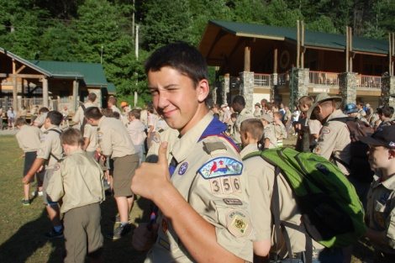
- Program
  - Summer Camp
    - Experienced record attendance of 4,972 and record positive surplus.

  - Continuous camp improvements
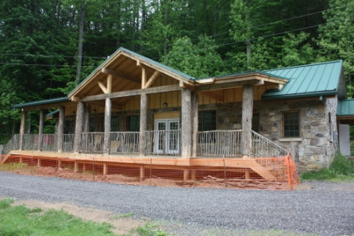
    - Numerous improvements thanks to generous benefactors and terrific volunteers including:
      - Renovated the Robertson Lodge
      - Extended the campfire circle for the Dixie Fellowship

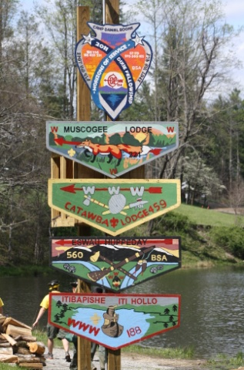
  - Tsali Lodge, Order of the Arrow
    - Hosted the Dixie Fellowship at Camp Daniel Boone (one of the largest conclaves in the country) serving over 1,200 Arrowmen!
    - Earned Lodge of the Year for the second consecutive year!
    - James Hylemon voted in as Section Chief
    - Honor Lodge
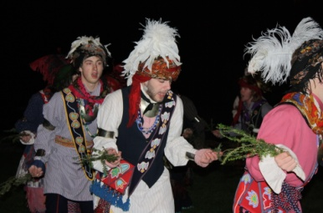

  - Advancement
    - 99 Boy Scouts earned the Eagle Scout Award
    - 185 Webelos earned Arrow of Light Award
    - Cub Scout advancement improved 23%
    - Boy Scout advancement improved 10%
    - Most common merit badges earned:
      - First Aid

      - Swimming
      - Citizenship in the World
      - Citizenship in the Nation
      - Environmental Science

  - Community Service
    - Council reported over 16,000 hours of community service!!
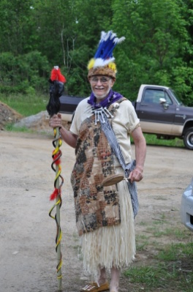
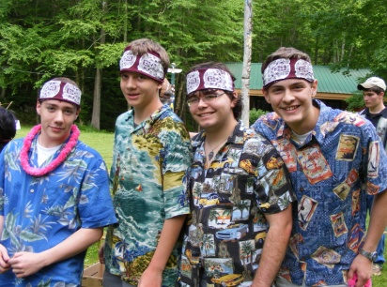
  - Castaway Odyssey draws over 800 to Camp Daniel Boone!
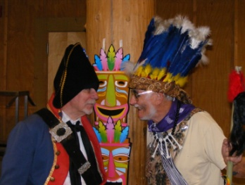
Council Statistics for 2011

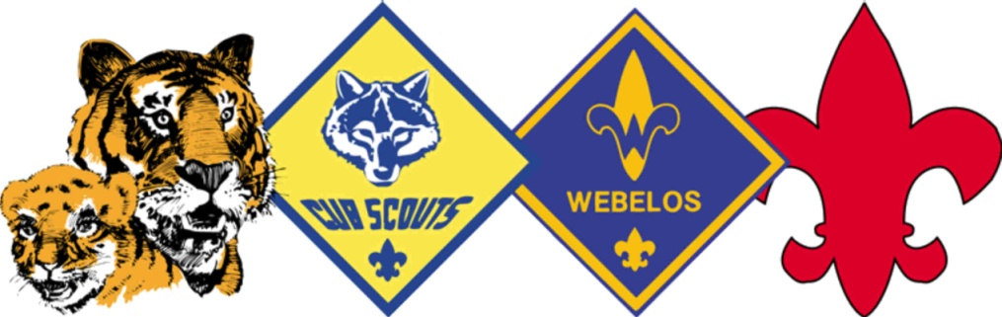
Membership
Tiger Cubs: 475
Cub Scouts: 1345
Webelos: 1060
Total Cub Scouts: 2880
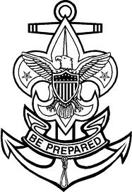
Boy Scouts: 1539

Venturers: 354
Total Traditional: 4773
Exploring: 152
Learning for Life: 52
Total Youth Served: 4977

Units
Packs: 77
Troops: 70
Crews and Ships: 25
Total Traditional: 172
Explorer Posts: 14
LFL Groups: 6
Total Units/Groups: 192
Council Statistics for 2011

Finance
- Managed a balanced operating fund with a surplus for the third consecutive year!
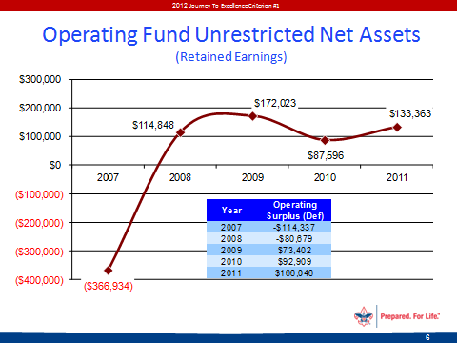


- Earned 2nd Consecutive National Direct Support Award
  - Exceeded Friends of Scouting campaign goal for the third consecutive campaign!
  - 4 of 6 campaigns achieved 100% of campaign goal

2011-2012 Executive Board Roster

2011-2012 Executive Committee
Council President Bryant Webster
Council Commissioner Chris Morgan
VP Finance / Treasurer Joel Chambers
VP Membership Dr. Stephen Page
VP Program Kathy Eaton
VP Manpower Richard Hurley (P)
VP Administration Bill Arledge
VP Marketing George Pfeiffer, Jr.
Legal Counsel Christopher B. Reinhardt

2011-2012 Executive Board Members (P) Indicates Past President
C.J. (Pete) Armstrong
Randall Barnett
Ronnie Blythe
Dr. Laurel Broadhurst
David Burrell
Bill Dyar
Hank Dunn
Neal Ensley
Dr. Jack Frisch
William R. Goacher (P)
Jerry Gmyr
Greg Hutchins Bob Litten
Ed McFarland (P)
Peggy Melville
Sue Persons
Mark Pinkston
Arnold (Skip) Sheldon
Steve Sizemore
Peter H. Sprague, Jr. (P)
Betty Taylor
Dr. Charles Vizzini
Ted White
David Whitson (P)
Charles Wolfe

2010-2011 Youth Representatives:
Order of the Arrow: Cameron Barnett
Venturing Officer’s Association: Nathaniel Broadhurst

2010-2011 District Chairmen

Cataloochee Clay Dangerfield
Nantahala Keith Lovin
SoQua Tom Knoebber
Terrora Ronald Justice
Toe River Taylor Townsend

2010-2011 District Commissioners

Cataloochee Sue Persons
Nantahala Phil Keller
SoQua Scott Davis
Terrora Wendy Henderson
Toe River Tracy McIntyre

2010-2011 ADVISORY BOARD MEMBERS (P) Indicates Past President

Tom Atkinson
Carleton Collins
Ray Dean (P)
George Escaravage (P)
Larry Hinton
Bill Huters
Phil Keller
Bob McAfoos (P)
Leon Rocamora (P)
Dr. David Sink
Frank Smith
Jonathan Smith
G. Stuart Thorp

Cataloochee District
2011 Eagle Scouts
Eagle Scout is the highest advancement rank in Scouting.
In Scouting’s Centennial year, 50,176 Scouts earned the rank of Eagle Scout.
Around 5 percent of all Boy Scouts earned the Eagle Scout rank in 2010.
6% of Boy Scouts in the Daniel Boone Council earned the Eagle Scout rank in 2010.
In 2010, the average age of boys earning the Eagle Scout rank was 17 years of age.
From 1912 to 2010, more than two million Boy Scouts earned the Eagle Scout rank.
James | Arthur | Stewart | T-202
Sean | Michael | Nilan | T-282
Raymond | Walter | Ezell | T-309
Greg | Dexter | Honeycutt | T-309
Colton | Tanner | Ward | T-309
Donny | Warren | Mattingly | T-316
Zachary | Bryant | Page | T-316
Samuel |  | Pinkston | T-316
Blaine | Lewis | Williams | T-316
Levi | James | Grasty | T-318
Benjamin | Charles | Tetreault | T-318
Matthew | Joseph | Long | T-322
Brandon | Lee | Stevens | T-322
Kristofer | Ray | Haney | T-333
Carson | S | Mease | T-333
John | Michael | Dowdy, Jr. | T-370
Kyle | Robert | Bigmeat | T-930
Nantahala District
Jacob | Daniel | Gilbert | T-401
David | Matthew | Kelley | T-401
William | Charles | McCray | T-401
Zachary | Steelman | Pyle | T-401
Toe River District
James | Ian | McIntyre | T-502
Henry | Isaac | Flint | T-505
Christopher | Lane | Lettner | T-505

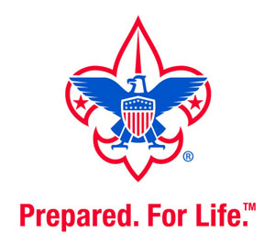

2011Eagle Scouts
Eagle Scout is the highest advancement rank in Scouting.
There were 51,473 Scouts who earned the rank of Eagle in 2011.
5.6 percent of all Boy Scouts earned the Eagle Scout rank in 2011.
6.4% of Boy Scouts in the Daniel Boone Council earned the Eagle Scout rank in 2011.

SoQua District
2011Eagle Scouts
Eagle Scout is the highest advancement rank in Scouting.
There were 51,473 Scouts who earned the rank of Eagle in 2011.
5.6 percent of all Boy Scouts earned the Eagle Scout rank in 2011.
6.4% of Boy Scouts in the Daniel Boone Council earned the Eagle Scout rank in 2011.

Nathaniel | David | Hensley | C-015
Leland | Bryson | Christy | T-0017
Jeffrey | Lance | Hutchins | T-003
James | Luke | Ball | T-008
Paul | James | Humble | T-008
Kiffen | McKeehan | Loomis | T-008
Austin | C | Lucke | T-008
Zachary | Talbot | Mitchell | T-008
Dylan | Manx | Morris | T-008
Stuart | Alec | Uritis | T-008
James | Simpson | Wilcox IV | T-008
Alexander | Gregory | Yount | T-008
Kevin | Alan | Goettge | T-015
Ronald | Eric | Morin II | T-015
Ethan | Holden | Pearce | T-022
Brian | Matthew | Cypcar | T-026
Alexander | Mckinley | Moffitt | T-026
Victor | Manuel | Rodeia | T-026
Tanner | Clayton | Smith | T-026
David | Alan | Winchester | T-026
Seth | Aaron | Wright | T-026
Christopher | William | Bolick | T-040
Logan | P. | Caldwell | T-045
Adam | D | Monroe | T-045
Matthew | Simon | Brouwer | T-050
Caleb | Joseph | Guffey | T-050
Hunter | Logan | Kruse | T-050
Kyle | Walker | Phillips | T-050
Christopher | L | Jones | T-053
Ian | Christopher | Moore | T-053
Brandon | Scott | Muncy | T-053
Joseph | Tyler | Foxx | T-057
Philip | Michael | Estes | T-072
Andrew | Jon | Vannice | T-073
Nathaniel | Scott | Rennard | T077
David | Laurence | Cobb III | T-077
Brandon | Coleman | McArthur | T-077
Stewart | Andrew | McCullough | T-077
Gabriel | Francis | Moraga | T-077
Michael | Andrew | Schill | T-077
Spencer | Aaron | Voigt | T-077
Phillip | Thomas | Blackburn | T-091
Maxim | Wayne | Goodman | T-091
Samuel | Wriston | Knecht | T-091
Matthew |  | Newcomer | T-091
Paul | Andrew | Wadhams | T-091
David | Allen | Long | T-103
Kyle | Joseph | Smith | T-138
David | Remenar | Greene | T--53
Terrora District
2011Eagle Scouts
Eagle Scout is the highest advancement rank in Scouting.
There were 51,473 Scouts who earned the rank of Eagle in 2011.
5.6 percent of all Boy Scouts earned the Eagle Scout rank in 2011.
6.4% of Boy Scouts in the Daniel Boone Council earned the Eagle Scout rank in 2011.

Jay | Jagdishbhai | Desai-Butler | T-601
Andrew | Daniel | Jacober | T-601
William | Cole | McKibbin | T-601
Konrad | Gaylord | Sanders | T-601
Matthew | CE | Johnston | T-602
Landon | Alan | Justice | T-602
Derek | H. | Cass | T-605
Omar |  | Cruz | T-611
Donovan | Morgan | Turner | T-611
William | Robert | Bayless | T-613
Taylor | Dalton | McGraw | T-613
Anthony | Edwin | Moore | T-613
Daniel | Patrick | Russell | T-613
Cody | Spencer | Shipman | T-613
Brian | Gregory | Albea | T-622
Brandon | David | Johnson | T-622
Austin | Zachery | Woodard | T-622
Nathan | Christopher | Conner | T-624
Landon | Kent | Siske | T-624
Peter | Hester | Lampley | T628
Edward | Marxer | Critikos | T-628
Joshua | Michael | Wentzel | T-628
Wesley | Cole | Holland | T-701
Ben | Lucas | Onnik | T-703

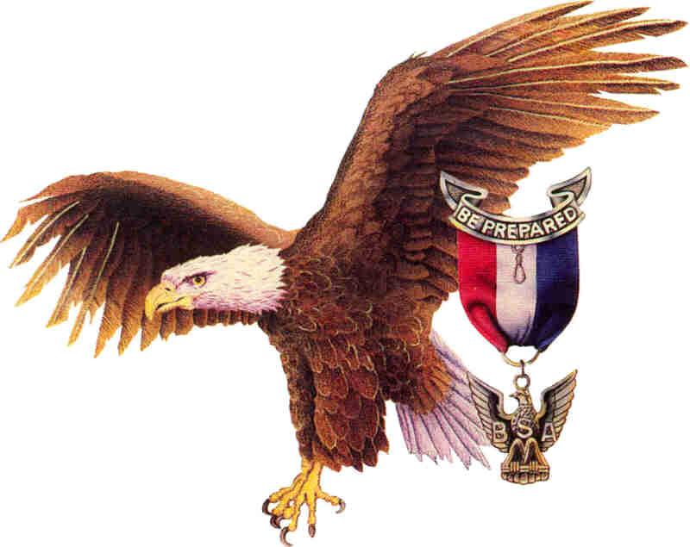

2011 Daniel Boone Council Chartered Organizations
CHARTERED ORGANIZATIONS
Abernethy United Methodist Church

Overview of Chartered Organizations
- Approximately 115,000 Scouting units are owned and operated by chartered organizations. Of these:
- 68.4 percent of all units are chartered to faith-based organizations
- 26.5 percent of all units are chartered to civic organizations
- 8.2 percent of all units are chartered to educational organizations
American Legion Macon Post 108
American Legion Post #2
American Legion Steve Youngdeer Post
Andrews United Methodist Church
Apple Valley Middle School
Asheville Fire & Rescue
Asheville Police Department
Avery County Sheriff's Office
Averys Creek Methodist
Bakersville United Methodist Church
Bald Creek United Methodist Church
Balfour Baptist Church
Balfour Education Center
Banner Elk Kiwanis Club
Bee Log PTO
Bell United Methodist Church
Bethel United Methodist Church
Bethel Wesleyan Church
Biltmore United Methodist Church
Black Mountain Fire Department
Blue Ridge Christian Church
Brevard Community Church
Brevard First United Methodist Church
Buncombe County Sheriffs Department
Camp Daniel Boone
Celo United Methodist Church
Central United Methodist Church
Cherokee Boys and Girls Club
Cherokee County Sheriff's Office
Cherokee Youth Center Boys & Girls
Christ School
Church of Jesus Christ of Latter Day Saints
Civil Air Patrol
Clay Co Lions Club
Clyde Central United Methodist Chur
Clyde Lions Club & Clyde Central UM
Covenant Presbyterian
Crossnore Volunteer Fire Department
Cruso United Methodist Church
Cullowhee United Methodist Church
East Asheville United Methodist Church
East Black Mountain Freewill Baptist
East Flat Rock Baptist Church
Emmanuel Lutheran
Etowah United Methodist Church
Fairview Baptist Church
CHARTERED ORGANIZATIONS
Fines Creek Fire Department

Responsibilities of Chartered Organizations
  - Providing adequate meeting facilities.
  - Providing quality leadership for the Scouting unit.
  - Appointing a chartered organization representative to coordinate all Scouting unit operations within the organization.

First Baptist Church
First Baptist Church of Newland
First Baptist Church of Waynesville
First Methodist Church
First United Methodist Church
First United Methodist Church of Franklin
First United Methodist Church of Hendersonville
Fletcher United Methodist Church
Franklin NC Presbyterian Men
Franklin Rotary Club
Fruitland Baptist Church
Getting Back to the Basics
Glen Arden Elementary School PTA
Glenn Marlow Elementary School
Grace Covenant Presbyterian Church
Groce United Methodist Church
Hayesville First United Methodist Church
Hazelwood Presbyterian Church
Henderson Co. Sheriffs Department
Hendersonville High School Alumni Association
Hendersonville Kiwanis Club
Hendersonville Lions Club
Hendersonville Middle School
Hendersonville Police Department
Higgins Memorial United Method
Highlands Rotary Club
Highlands United Methodist Church
Kiwanis Club Of Hendersonville
Knights of Columbus Council #8363
Longs Chapel United Methodist Church
Longs Chapel United Methodist Men
Lutheran Church of the Nativity
Macedonia Baptist Church
Mars Hill Baptist Church
Mars Hill United Methodist Church
Marshall 1st Baptist Church
Meadowbrook Freewill Baptist Church
Micaville Elementary School
Mills River United Methodist Church
Minneapolis United Methodist Church
Montmorenci United Methodist Church
Montreat Presbyterian Church
Mount Zion Baptist Church
Mountain Health Education Center Inc.
Mt Moriah Baptist Church
Mtn. Heritage High School
NJROTC Unit Pisgah High School
Oak Hill United Methodist Church
CHARTERED ORGANIZATIONS

Overview of Chartered Organizations
- Civic, faith-based, and educational organizations operate Scouting units to deliver the programs to their youth members, as well as the community at large.

Oakley United Methodist Church
Otto Community Development Organization
Parkway Fire Department
Peachtree UMC
Pinecrest Presbyterian Church, ARP
Pinnacle Church
Progressive Ed. Program & Asheville Optimist Club
Project Challenge Inc.
Project Soar
Riceville Community Center
Riverside Elementary PTO
Robbinsville Lions Club
Rockwood United Methodist
Rotary Club
Rotary Club of Franklin - Daybreak
Skyland United Methodist Church
South Macon Methodist Men
Spruce Pine United Methodist Church
St Pauls United Methodist Church
The Edneyville Grange
The Episcopal Church of the Messiah
The Session Of Brevard-Davidson Riv
Trinity Presbyterian Church
Trinity United Methodist Church
Unity Healing Center
Veterans of Foreign Wars
Veterans of Foreign Wars Post 5483
VFW Post 891 / St Daniel Frank Hyatt
Volvo Construction Equipment
Waynesville Police Department
Weaverville United Methodist Church
West Burnsville Baptist
Yancey County Sheriffs Office



The Journey Continues….

